The Board of Commissioners has approved these Minutes and are the official record relating to the conduct or administration of the District's business, as reflected herein.

BOARD OF COMMISSIONERS MINUTES
Kuna Rural Fire District
Regular Meeting April 9, 2025

OPEN REGULAR MEETING
Commissioner Burn called the regular meeting of the Kuna Rural Fire District Board of Commissioners to order April 9, 2025, at 9:30 am.

COMMISSIONERS PRESENT
Commissioner present at the meeting included Commissioner Rebekah Luther, Commissioner Scott Burn, Commissioner Carrera Atkinson, Commissioner Dawn Hale, and Commissioner Robert Hilpert.

Additional individuals present included Attorney Marc Bybee, Chief TJ Lawrence, Kristin DeRoos, and Krystal Hinkle.

Consent agenda approval
Commissioner Hale made a motion to approve the Consent Agenda as printed and posted. Seconded by Commissioner Luther. Approved unanimously.
- Approval of the Agenda
- Approval of the Board Meeting Minutes dated March 12, 2025 and Special Board Meeting minutes dated March 7, 2025.
- Approval of the Financial Reports including the funds investments, approval of bills, accounts payable, and Impact Fee Account Balances.

PUBLIC INPUT/DISCUSSION
- No Public Discussion

STAFF REPORTS

Chief Report, TJ Lawrence
- Idaho Emergent Management, Incident Management Team, Type 3 team
- One Firefighter on Light Duty, One Firefighter on Workman’s Comp
- One Firefighter gave verbal confirmation that he is retiring on May 27th.
- Architect with final estimate for adding admin building.
- MOU – Diode
- Rescue Drop Off
- Veteran’s Program

LOCAL 4165 REPORT
- Life Jacket Station
- June 16th Golf Tournament

ATTORNEY REPORT
Marc Bybee
- Discuss Agenda, Legislature Report, Threshold of Procurement, Open Meeting consent agenda restrictions, Fire District Consideration.

OLD BUSINESS:
- State Fire Commissioners Association Report/Update
- Ada County – City EMS System (ACCESS) update – meeting later in April
- Discuss and Consider Resolution approving wages and benefits for James Trumble – there was a Motion to Table made by Commissioner Luther and seconded by Commissioner Hale. Approved unanimously.
- Discuss and Consider Resolution modifying Policy Code for Assistant Chief, Title 5, chp 1 – Motion to Table made by Commission Hale, seconded by Commissioner Luther. Approved unanimously.

NEW BUSINESS:
- Discuss and Consider Resolution Approving the Amended District Dog Policy
  - Chief kept a running log, at first there were a couple complaints but everything was handled quickly. There was a motion to approve Resolution 2025-06 by Commissioner Hale, seconded by Commissioner Atkinson. Approved unanimously.
- Discuss and Consider Resolution for the Purchase of New Engine
  - Marc Bybee expressed concern by the language of the quote. James Trumble mentioned that the Quote srates the terms to get the purchase agreement going and that signing the quote doesn’t obligate the district to buy the engine. Board members have concerns with signing the Quote without written language stating the protection.
  - A motion was made by Commissioner Atkinson and seconded by Commissioner Hale to direct Chief to sign the quote providing condition that the statement in writing is not binding. Approved unanimously.
EXECUTIVE SESSION
Commissioner Burn made a motion and Commissioner Atkinson seconded that motion to enter an executive session pursuant to

Idaho Code § 74-206(1)(b) to consider the evaluation, dismissal or disciplining of, or to hear complaints or charges brought against, a public officer, employee, staff member or individual agent.

and (j), to consider labor contract matters authorized under section 74-206A (1)(a) and (b), Idaho Code.

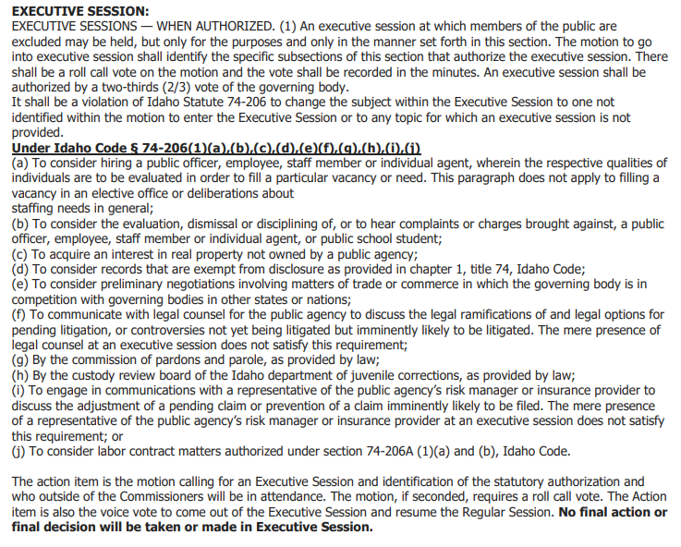

Verbal Roll Call:
- Commissioner Luther - yes
- Commissioner Burn - yes
- Commissioner Atkinson – yes
- Commissioner Hale – yes
- Commissioner Hilpert – yes

In attendance were Commissioners Hale, Burn, Luther, Atkinson, and Hilpert. Also in attendance were Marc Bybee, James Trumble (10:08 to 10:41), Krystal Hinkle (10:41 to 11:25), and James Trumble, Krystal Hinkle, and Kristin DeRoos from 11:41am to 12:16pm.

Commissioner Luther made a motion to come out of executive session. Seconded by Commissioner Atkinson. Approved.

Executive Session:
- Starting at: 10:08 am
- Ended at: 12:16 pm

OPEN SESSION RESUMED -POST EXECUTIVE SESSION BUSINESS
No action was taken by the Commissioner in Executive Session. Commissioner Atkinson Motions and Commissioner Burn Seconds a Motion for Resolution Approving Wages and Benefits for James Trumble. Approved unanimously.

SET DATE FOR NEXT MEETING
Discussion regarding May meeting, no date set yet.

ADJOURNMENT
Discussions
With no further discussion, the meeting was adjourned. Commissioner Luther made a motion to adjourn, Commissioner Atkinson seconded the motion. Approved unanimously. Meeting adjourned at 12:22pm.

The Board of Commissioners has approved these Minutes and are the official record relating to the conduct or administration of the District's business, as reflected herein.

